The Story of the Origin of the Universe

Hub VIP: Watch video here
(Access the videos and get 15% off a new Hub VIP membership with code GETVIDEOS - click here!)

Note: Please see the Resource Guide for the experiments/demonstrations.

Original impressionistic (hand-drawn charts): purchase here

*********

In the beginning there was only the deep, an immensity of space with no beginning and no end, indescribably dark and cold. Who can imagine that immensity, that darkness and coldness?

When we think of the dark, we think of night but our night would be like brilliant sunshine in comparison with that darkness. When we think of cold, we think of ice. But ice is positively hot if you compare it with the coldness of space, the space that separates the stars: as hot, you might say, as a blazing furnace from which no heat can escape.

Experiment#1 ‘Colder than Ice’

In this measureless void of cold and darkness light was created. There appeared something like a vast fiery cloud that included all the stars that are now in the sky: the whole universe was in that cloud, including our Earth. But they were not stars or planets then: as yet there was nothing except light and heat. So intense was the heat that all the substances we know - iron, gold, earth, rocks, water - were gases, as insubstantial as the air. All these substances, all the materials of which the earth and the stars are composed, were fused together in one vast, flaming intensity of light and heat - a heat which would make our sun today feel like a piece of ice. This raging fiery cloud of nothingness, too huge to imagine, moved in the immensity of freezing space, which was also nothingness but infinitely vaster. The fiery mass was no bigger than a drop of water in the ocean of space: but that drop contained the earth and all the stars, which are really blazing suns millions of times bigger than the earth.

As this cloud of light and heat moved through empty space little drops fell from it. Like when you swing the water out of a glass, some of it holds together as it falls and the rest breaks up into separate drops. The countless host of stars are like these drops. Only instead of falling, they are moving round in space, in such a way that they could never collide or meet again. They are millions of miles away from each other.

Indeed the stars are so far away that it takes the light of some of them millions of years to reach us. Do you know how fast light travels? 100 miles? 200 miles?1000 miles an hour...? No, much faster. light travels at 186,000 miles, (that is 300,000 km), not per hour but per second! Imagine how fast that is! it means in one second it can travel 7 times around the whole earth. And do you know how big the earth is? 25,000 miles (or 40,000 km) around (circumference.) If we were to drive at 100 miles an hour continuously, all day and all night long, without stopping, it would take us more than 10 days to cover that distance. And yet light covers that distance 7 times in one second. You do ‘click‘ with your fingers and light has travelled around the earth 7 times already!

So can you imagine how far some of these stars are, that it takes their light 1 million years to reach us? Then there are many stars that scientists have calculated that if each of them were a grain of sand, all the stars together would cover up the whole of England to a height of 200 metres (or Ireland / 400 m, or Alabama /200 metres). One of these stars, one of the grains of sand among those thousands of billions of grains of sand, is our sun, and one millionth part of this grain is our earth. An invisible speck of nothingness.

One wouldn‘t think so; the sun doesn‘t look so big. But that is because it is so far away. The light from it takes about 8 minutes to reach us and if we were to travel the distance at 100 miles per hour it would take us a little more than 106 years to reach the sun. In fact, the sun is 1 million times bigger than the earth. The sun is so big that one of its flames could contain 22 earths.

Chart 1a/MFE 1 (Flaming sun and tiny Earth)
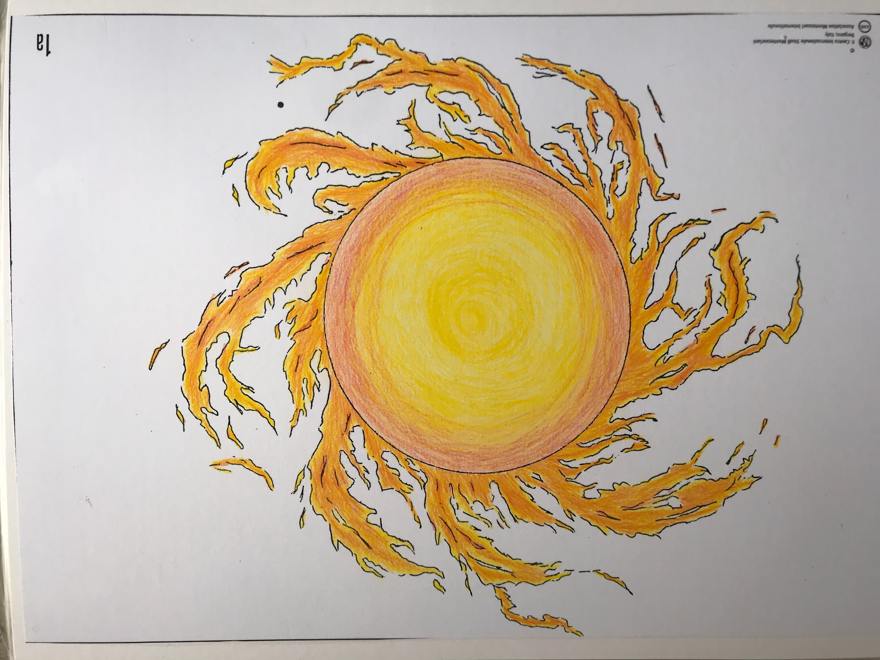

Every part of the universe, every speck which we might think too tiny to matter, was bound to behave according to certain laws. The drop of the blazing cloud which became our world slowly went from a burning confusion of gases to air and water and rocks.

The blazing mass of the earth was made up of infinitesimal particles and it was they themselves that would be transformed into rocks and water and air. The shape (form) they took depended on how hot or cold they were. These particles, inconceivably small and all merged together, were whirling at a fantastic speed.

As they cooled, they moved more and more slowly, clinging closer and closer to each other and occupying less and less space. This is what we call the three physical states of matter: everything we know is either a gas or a liquid or a solid, and which of the three it is at any given moment depends on how hot or cold it is.

Experiment #2, ‘Solid, Liquid and Gas ‘

Why then, we may ask, are there such millions and millions of particles, each with its special instructions: each was given a special love for certain particles and a special dislike for others. Just like human beings, they are attracted to some individuals, and refuse to have anything to do with others. So they form themselves into different groups.

Experiment #3 ‘Power of Attraction’

In the solid state, these particles cling so tightly together that they are almost impossible to separate. They form a body which will not alter its shape unless great force is applied to it. If a piece is broken off - if for instance you start chipping a flint - the particles still cling together: the flint and the chips remain solid pieces of stone.

When it came to liquids, the particles obeyed the law that said that they will hold together while they are inside a vessel and take the shape (form) of the vessel they are in. Outside, they shall flow and spread, filling every hollow and crevice in their path. They will not cling so closely to each other as the particles of a solid, but will be able to move and roll over each other.

Experiment #4 ‘Model of a Liquid’

They will push downwards and sideways, but not upwards.

And, since they do not cling so tightly to each other, they take up more room than the particles of a solid. And the gases follow a different law. Their particles do not cling together at all. They can move freely in all directions.

These are the rules the particles must follow, and so it is that they form themselves into solids and liquids and gases. But there are special conditions. Unless, the temperature is very, very hot, hotter than the heat of the sun, or very, very cold like the cold of outer space, they shall not be gases, or liquids or solids all at the same time. But at a certain degree of heat some of them shall be solid, some liquid and some gaseous.

Experiment #5 Different substances change their state at different temperatures

And if the heat increases, solids will become liquid, and the liquids will turn into gases which will mix with other gases; but not all the solids will become liquid at the same degree of heat.

And so, while obeying these laws, the little drop of nothingness that was to become our world, the blazing mass, went on spinning and spinning around itself and around the sun in the tremendous cold of space. And as time went on, the outer ring of this gas began to dance, a dance of the elements. The particles that were on the outermost edge became cold and shrank; huddling together they hurried to earth but as soon as they approached the hotter part they became hot and up they went again. Like little angels they carried a bucket of hot burning coal into space and returned with some ice.

Chart 3A (Angels carrying buckets)/MFE 3
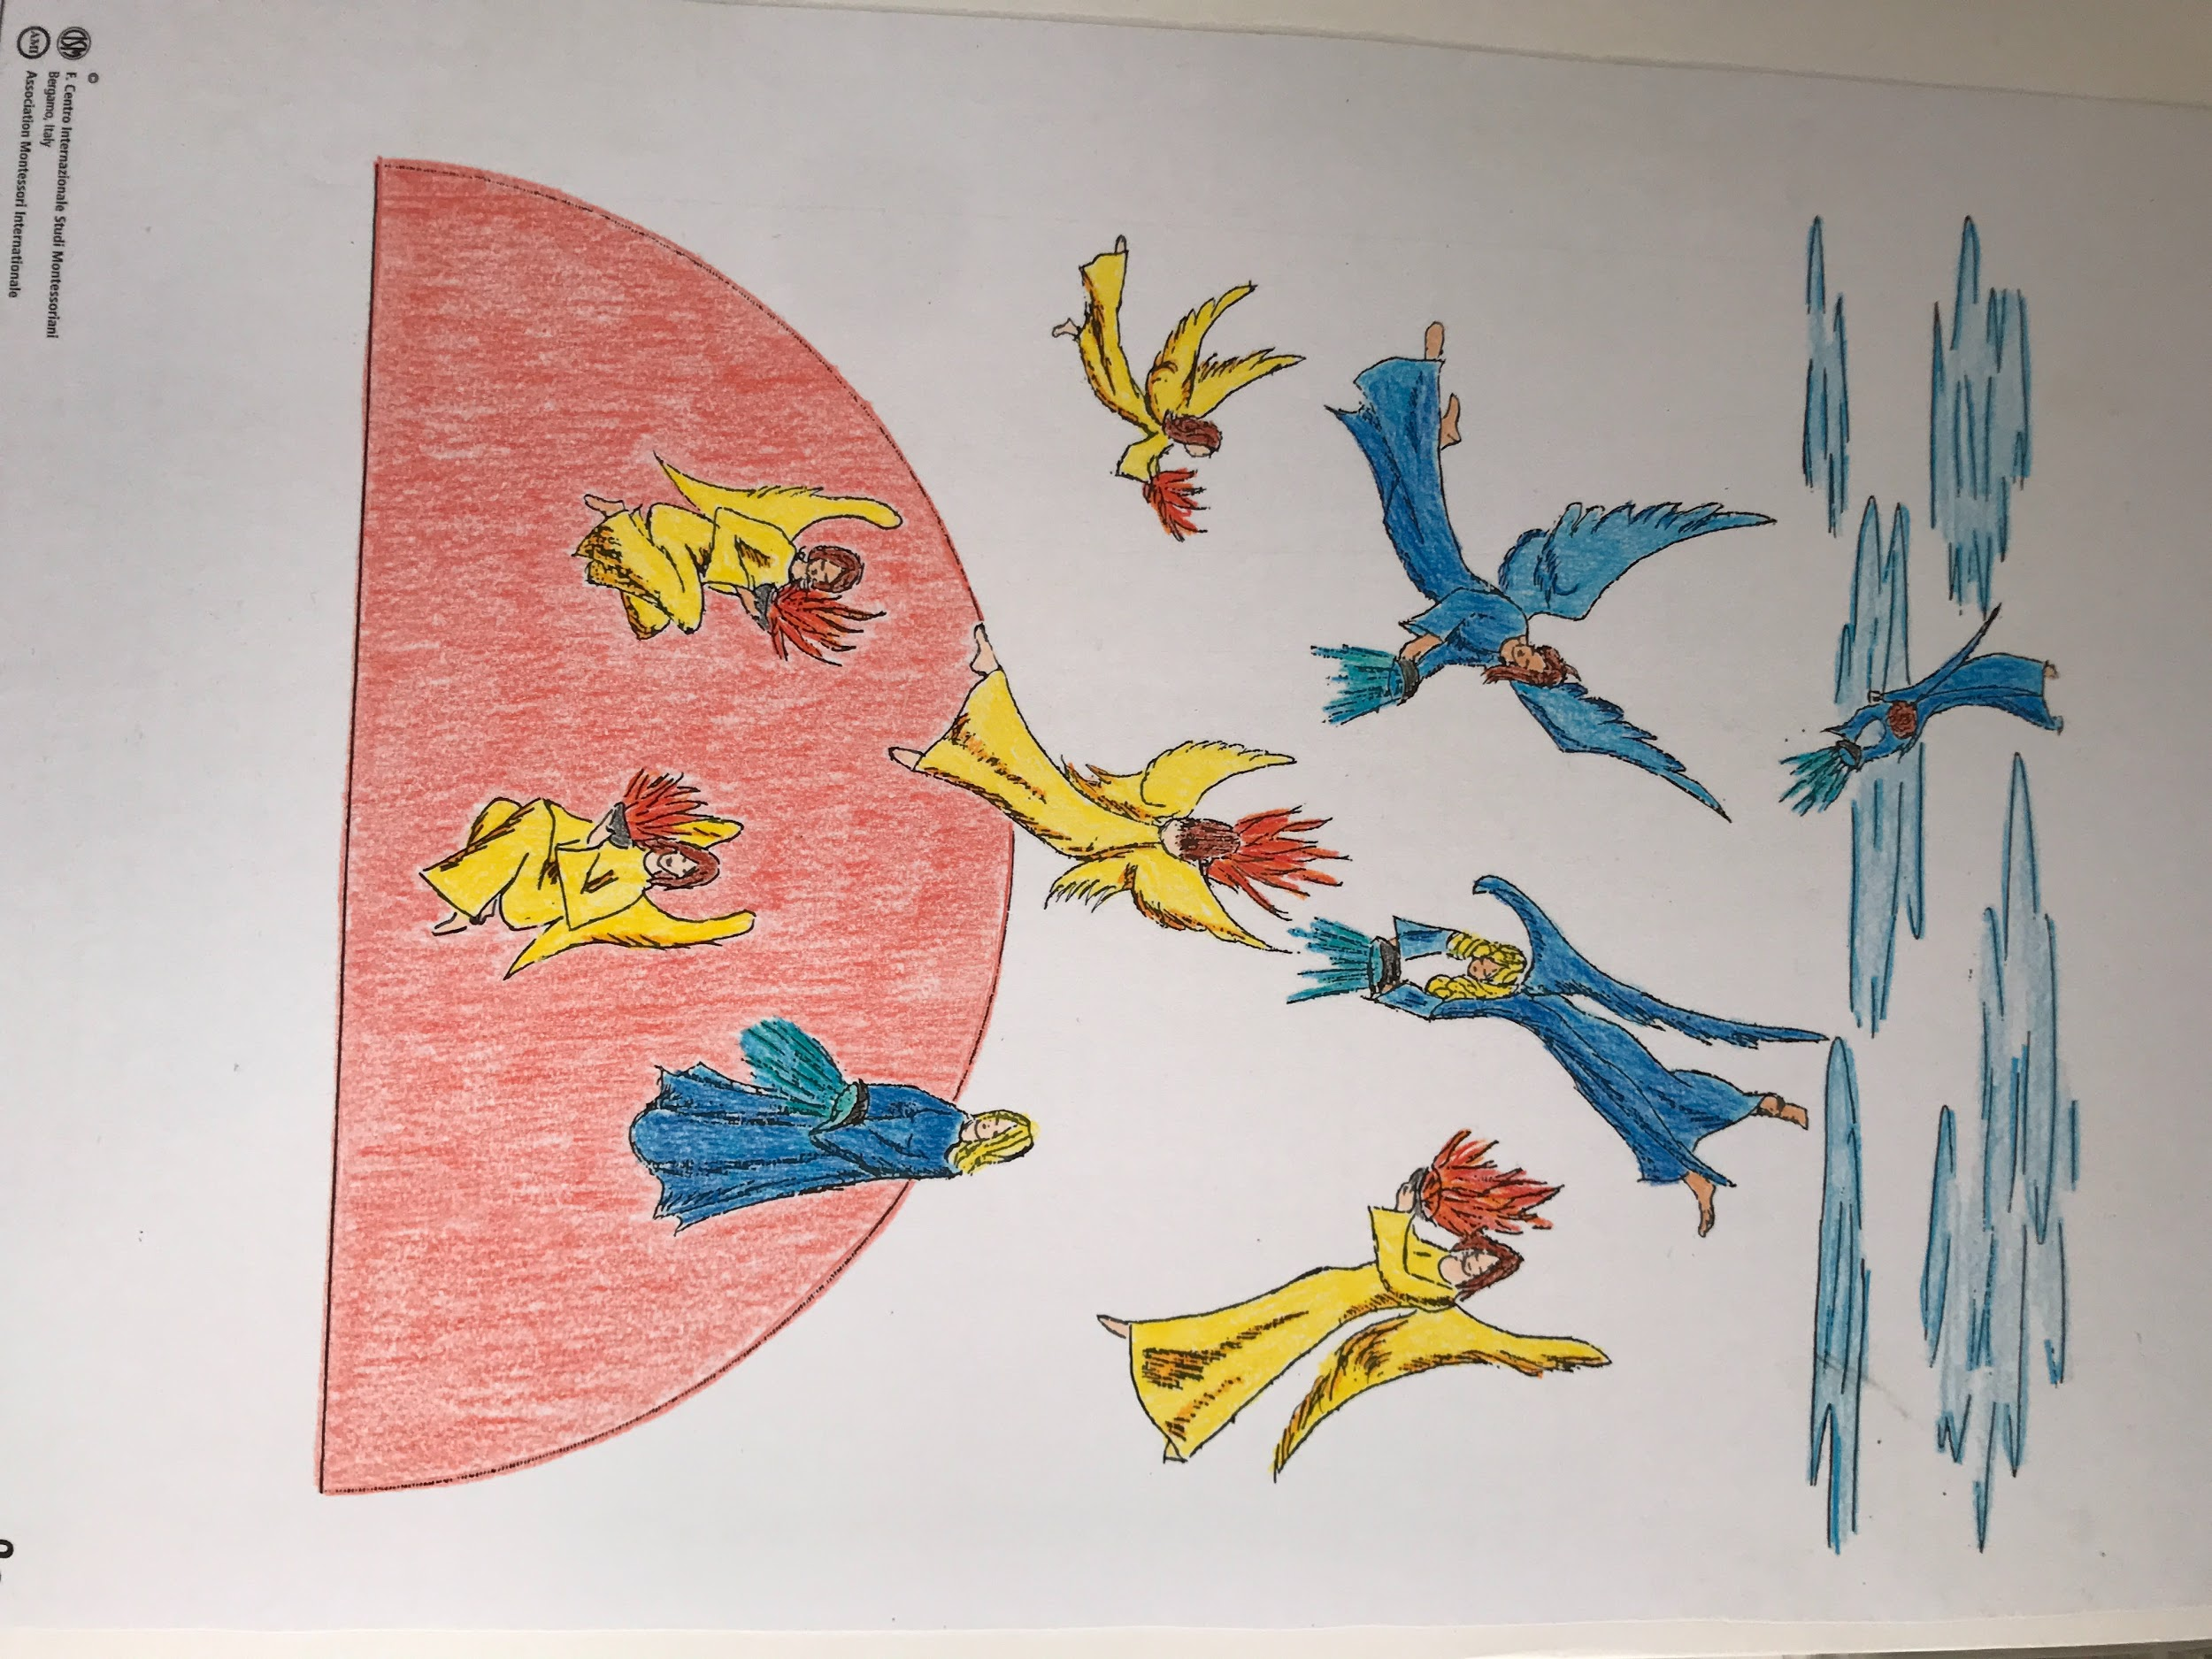

How marvellous it is! And how simple! If you become hot, you expand, and as you expand, you become lighter and soar upwards, like a bubble of air in water. But if you became cold you shrink and fall, just as a grain of sand sinks to the bottom of a pond. Because of this law the earth gradually changed from a ball of fire to the earth we know. This was the law that the tiny radiant particles obeyed as they danced their dance; particles too minute to be seen or even imagined, yet numerous enough to have produced the world.

For hundreds, thousands, millions of years this dance went on. Finally the particles settled down, like tired dancers, and one after another, they became first liquid and then solid and as they became solid or liquid some of them joined others to which they were attracted, forming new substances. The heavier ones went nearer the heart of the earth and the lighter ones floated above them like oil on water.

Experiment #6 “Liquids Settle According to their Weight’

A thin scum was formed, like the skin which forms on milk when it is boiled and left to cool. it seemed as if the earth had taken some shape. But the elements inside this skin were still very hot and they felt trapped. They wanted to get out. How could it be otherwise? They had to follow the law: if you are hot you expand. There was no place to expand and so they burst out. They broke the skin and it was like a terrible fight.

The water that formed on the surface turned immediately into vapour and went up as the hot stuff came out from inside the earth. There were also ashes. A veil of clouds was drawn to cover the earth so that nobody could see what was going on. The sun was ashamed of them.

Chart 4a (Errupting volcanoes)/MFE 4
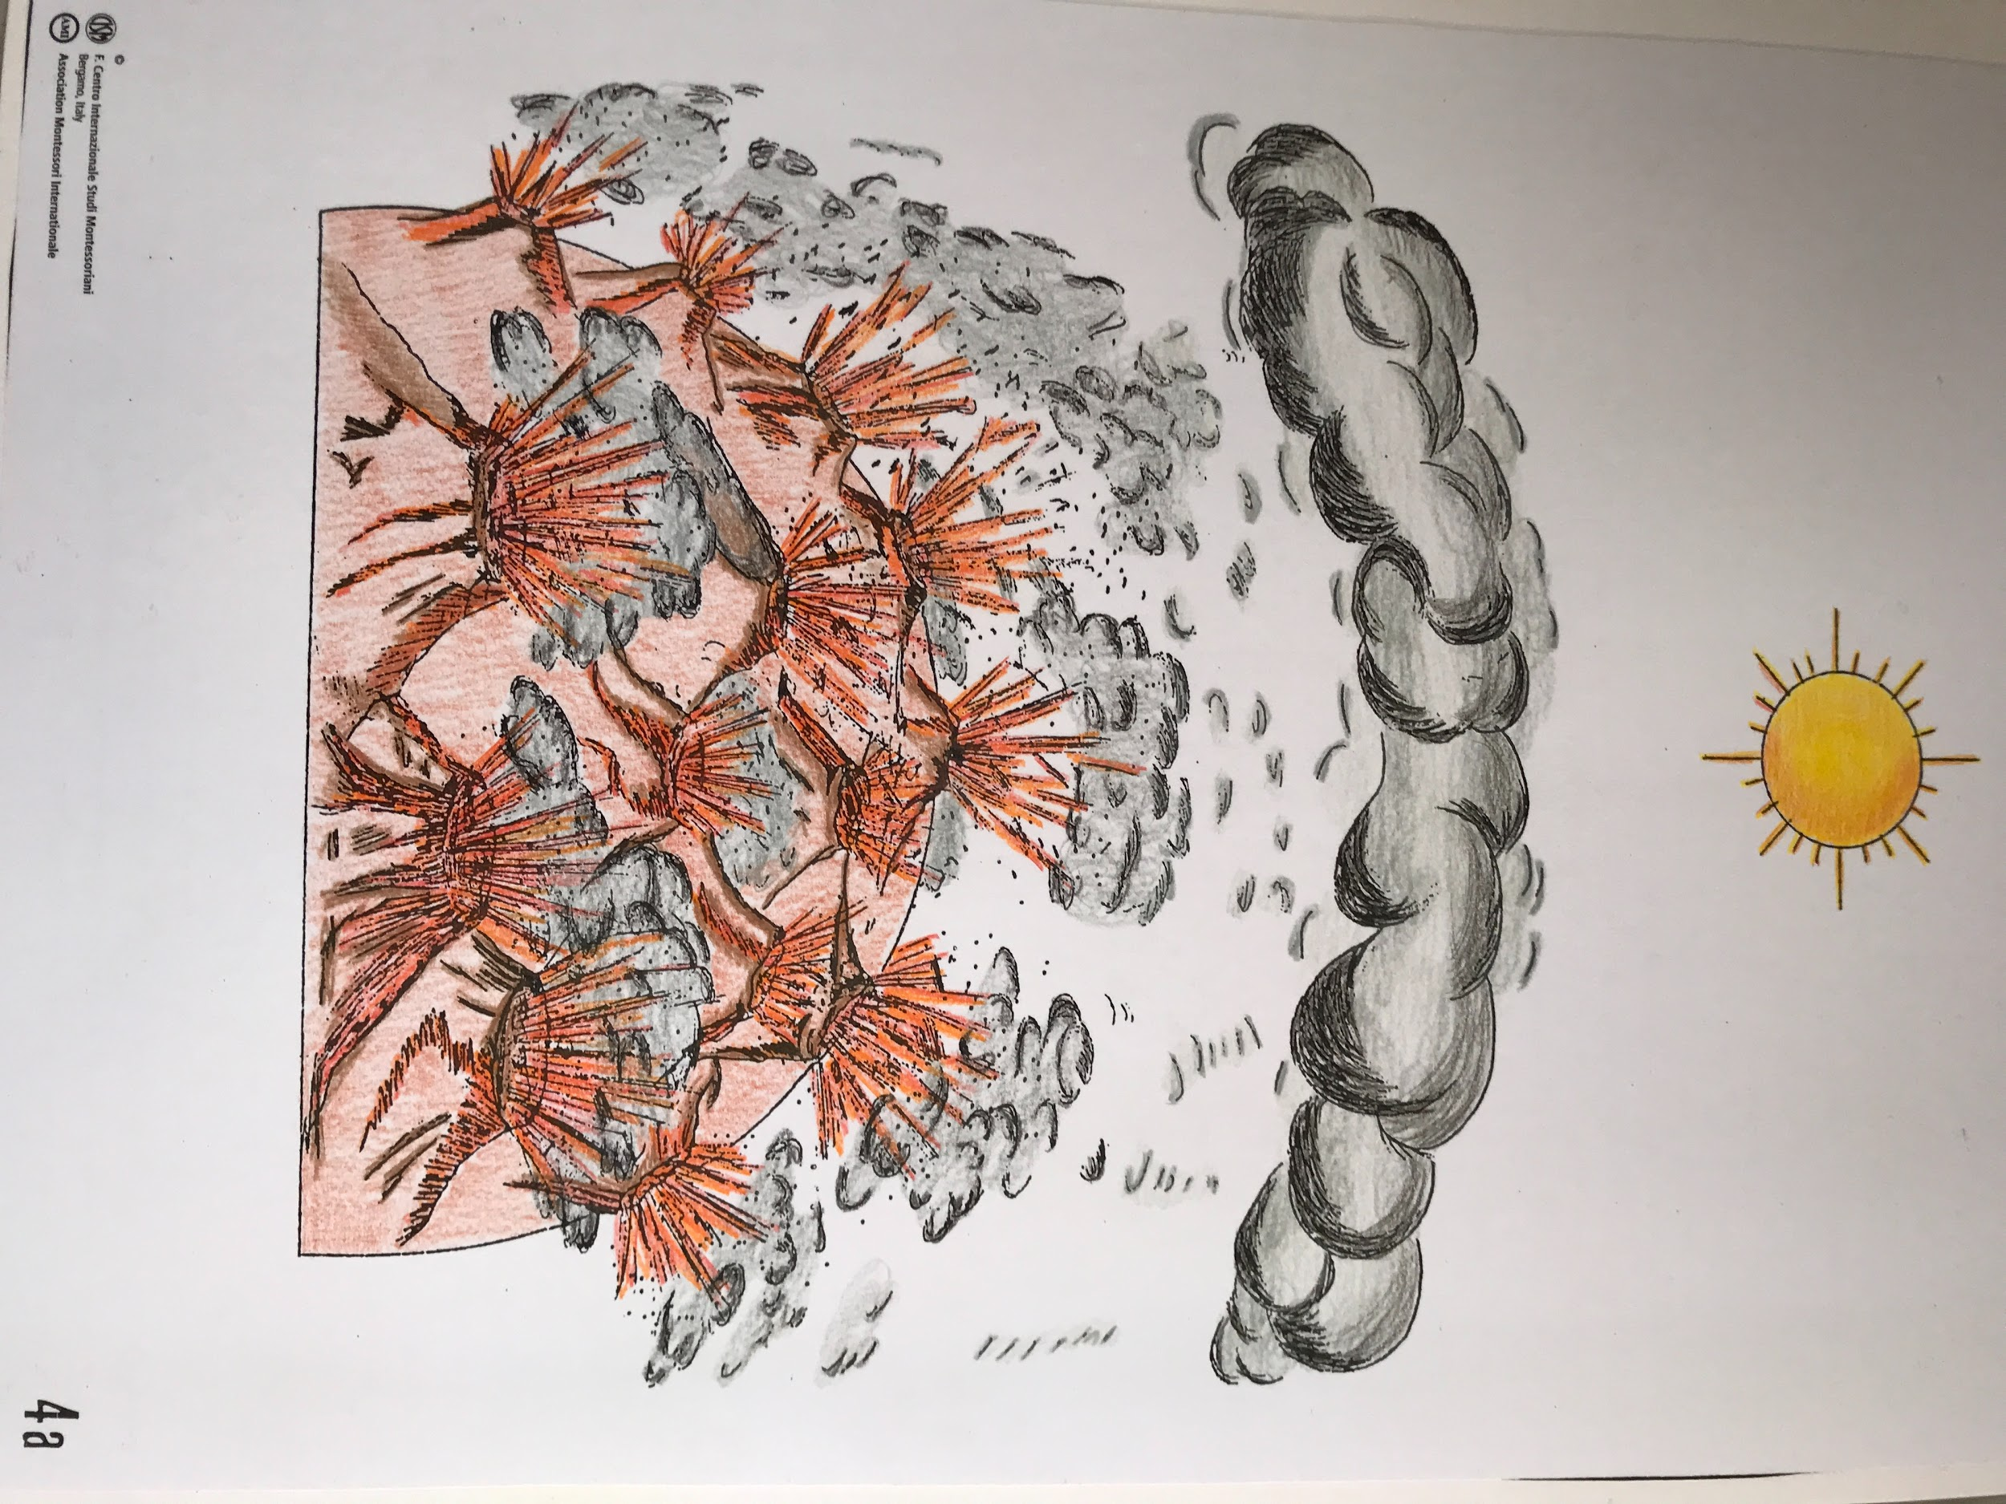

Experiment #7 ‘The Volcano ‘

Eventually the fighting ceased. As everybody cooled down, more and more gases became liquid, more and more liquids became solids. The earth formed, with wrinkles that are the mountains and hollows that are the oceans. For as soon as the rocks had cooled down, water was able to return to the earth and it rained and rained and rained. And the water, being liquid, filled every hollow and crevice it found in its path. Thus the oceans were formed.

Above them was air, the air that we breathe. The cloud had disappeared. The veil was withdrawn and the sun could once again smile upon its beautiful daughter, the earth.

Chart 5A (Blue Earth with dormant volcanoes)/MFE 5
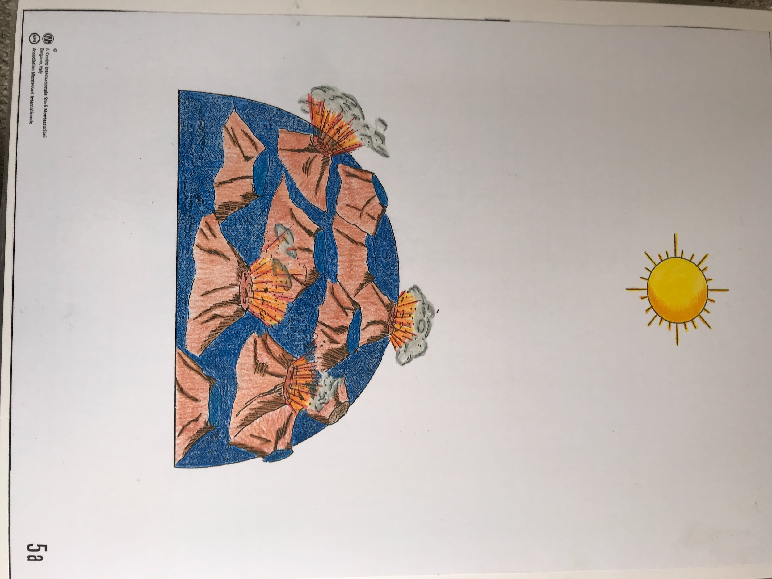

Rocks, water, air, solids, liquids, gases: each is what it is because of its degree of temperature. Today, as it was yesterday and a million years ago, these laws are obeyed in the same way. The world spins round and round itself and round and round the sun. And today, as it was a million years ago, the earth and all the elements and compounds of which it is composed follow the laws and fulfill their task.

